Transbaviaans Map installation:

Please follow these instructions below for a successful installation.

1. Extract the zip folder.
2. Double click on the file Transbaviaans Garmin Map 2014 version 1.exe file (**Windows**) / T4A 9106.gmapi.zip file (**MAC**). The map installation screen will immediately appear on the Windows PC, with the MAC you will still need to double click on the T4A_9106.gmapi file for the map to install on your MAC.
3. Once the map is installed, return to the Transbaviaans folder and double click on the Transbaviaans Tracks 2014.gpx file, Garmin BaseCamp will open up with the required waypoints and routes.

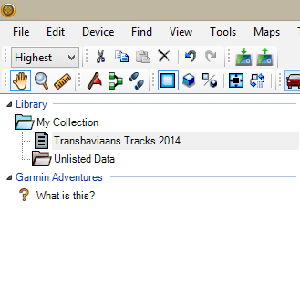

Select these steps below to transfer the map from your PC to your GPS device;

**Windows:**

**If you already have BaseCamp on your PC, go to HELP – CHECK FOR SOFTWARE UPDATES to make sure you are using the latest version**. The steps below are applicable to BaseCamp v3.3.3 (or later) and MapInstall v4.0.1 (or later).

When sending the map/s, MapInstall should be open and your GPS system switched on and plugged in. **Each time a map set is sent to a Garmin GPS the previously loaded maps are erased from the GPS**. If your Garmap maps are on your SD card, send your T4A maps to the internal memory on your device and vice versa.

To transfer maps to your device, open BaseCamp.

If you want to transfer maps to the internal memory of your device, right click on ALL DATA – INSTALL MAPS ON (your device name).

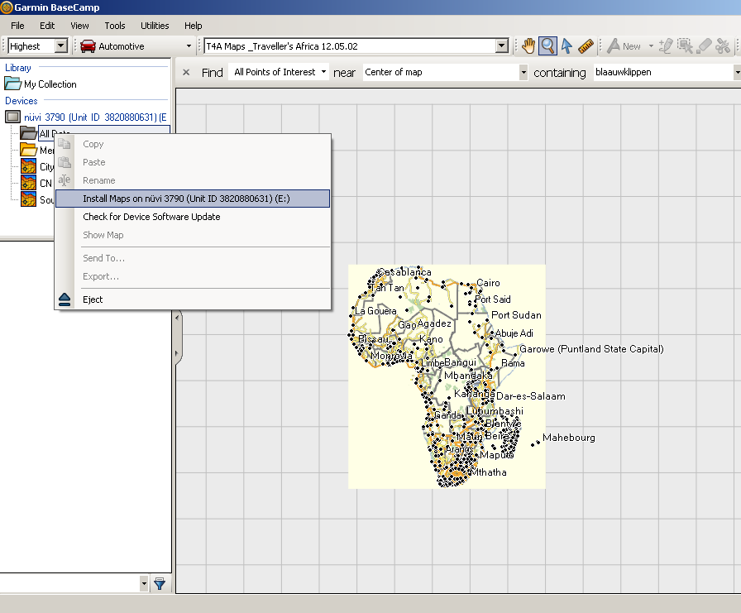

If you want to transfer maps to the SD card in your device, right click on MEMORY CARD – INSTALL MAPS ON MEMORY CARD.

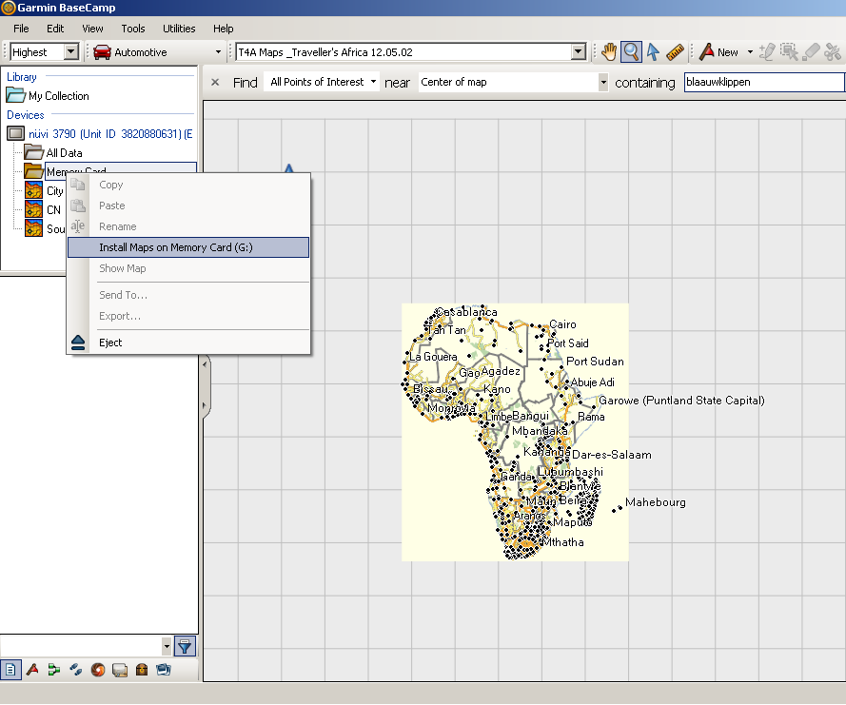

MapInstall will open and list your device. Click on CUSTOMIZE to select the map(s) you want to send to your device.

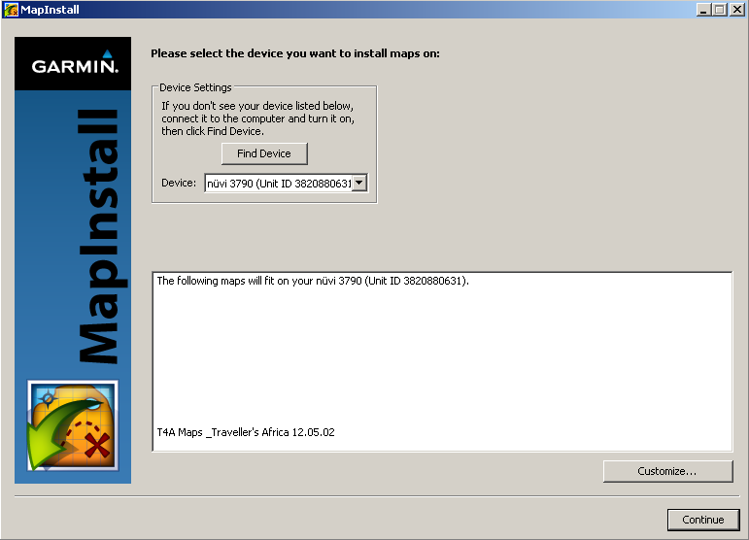

Click on the map name of the map that you want to send to your device. Your map will be highlighted on the screen. Click on continue:

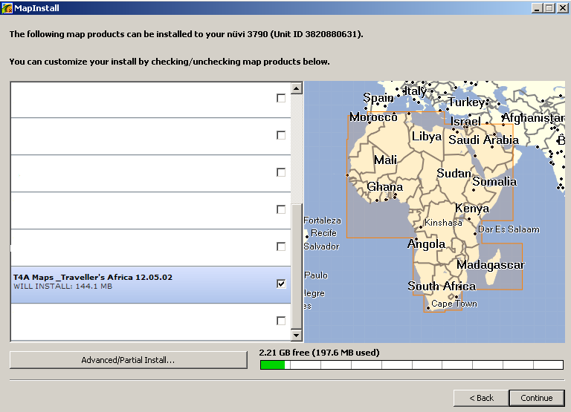

Click on install:

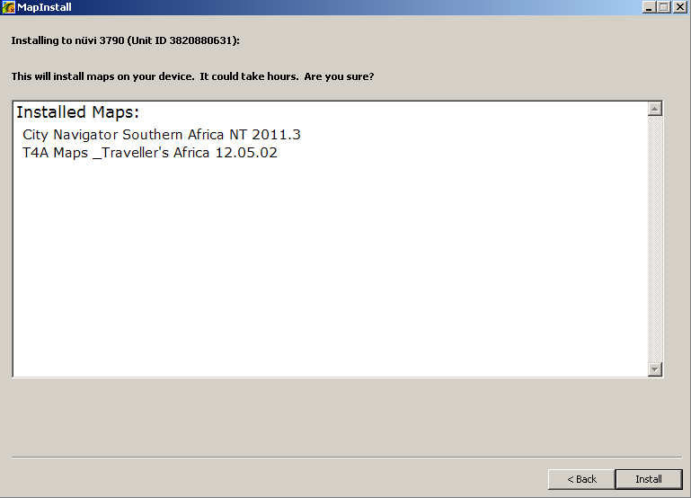

The following screen will appear:

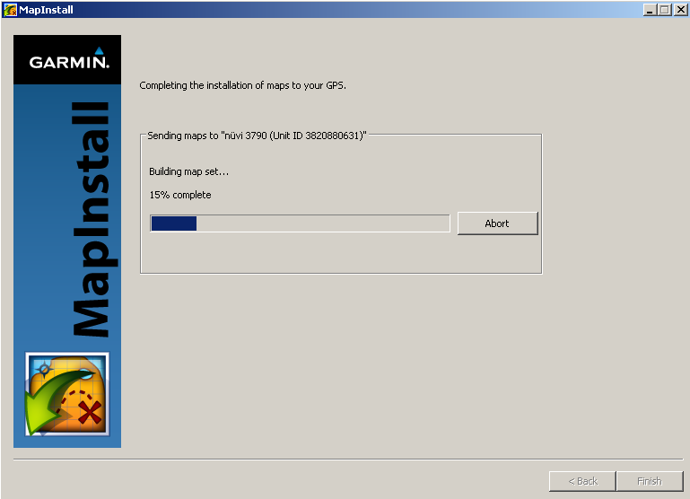

This can take a few minutes (note it shouldn’t take hours). When the installation is done, click FINISH.

To check whether the maps were successfully sent, switch on your Garmin GPS device, go to TOOLS – SETTINGS – MY MAPS and check whether T4A is listed (note steps to check whether the maps are loaded may vary depending on which GPS you’re using).

**MAC:**

|  |  |
| --- | --- |
|  | If you are using a Mac you need **BaseCamp** to view the map(s) and to do route planning on your computer and **MapInstall** to send the map(s) from your computer to your GPS device.   1. **Downlaod Basecamp for Mac:**   <http://www8.garmin.com/support/download_details.jsp?id=4450>  Or, if you already have Basecamp installed, make sure you are using the latest version of Garmin BaseCamp by going to HELP – CHECK FOR SOFTWARE UPDATES.   1. **Download Mapinstall for Mac:**   <http://www8.garmin.com/support/download_details.jsp?id=3825/>  The steps below are applicable to MapInstall v4.0.1 (or later).  **To transfer waypoints, routes and tracks to your GPS using Garmin BaseCamp for Mac’s:**  Open BaseCamp. Go to TRANSFER – click on SEND “My Collection”. This window will open on your screen. Select your GPS or No Name from the drop down menu. If you select you’re GPS the data will be transferred to the **internal memory** of the GPS, if you select the No Name device then the data will be transferred to **the SD card in your GPS**.  Ensure that **ROUTES, TRACKS, WAYPOINTS AND GEOTAGGED PHOTOS** are ticked. Click then on Send  Screen shot 2012-08-14 at 12.38.41 PM.png  Click on Close after the transfer has been completed. All your waypoints will be listed on your GPS under Favourites. If you GPS can receive routes then the routes you’ve created will be listed under your Trip planner (depending on your GPS model).  Screen shot 2012-08-14 at 12.39.24 PM.png  **To transfer the map(s) to your Garmin GPS using Garmin MapInstall:**  **Each time a map set is sent to a Garmin GPS the previously loaded maps are erased from the GPS.** If your Garmap maps are loaded on your SD card, send T4A maps to the internal memory of your device and vice versa. Please note that the SD card has to be inserted in the GPS device if you want to transfer maps to the SD card.  Your GPS device should be connected to the Mac and switched on when transferring maps.  **Step 1:** Open MapInstall by clicking on **Go** on your toolbar and selecting **Applications** - **Garmin MapInstall**.  **To transfer maps to your device internal memory**, remove the SD Card form you’re GPS and insert the GPS unit into your Mac. The GPS will be listed like this below (example) **Nuvi 3790 (unit ID 3820880631)**  Screen shot 2012-08-14 at 12.10.52 PM.png  **If you want to transfer maps to the SD card in your device**, then insert the SD Card in your GPS and plug it into your Mac. The GPS will be listed like this below (example) **Nuvi 3790 (unit ID 3820880631)+ SD Card**  Screen shot 2012-08-14 at 12.21.03 PM.png  **Step2:** Click on CUSTOMIZE to select the map(s) you want to send to your device.  Screen shot 2012-08-14 at 12.21.03 PM.png  **Step 3:** Click on the map name of the map that you want to send to your device. Your map will be highlighted on the screen.  Screen shot 2012-08-14 at 12.24.49 PM.png  **Step 4:** Click on Send Maps on the bottom right hand corner of MapInstall to transfer the maps to your GPS device.  Screen shot 2012-07-25 at 1.00.10 PM.png  **Step 5:** The following screen will appear below. Click on confirm. Please note that they transfer should not take hours as indicated below.  Screen shot 2012-08-14 at 12.27.16 PM.png  **Step 6:** Once the transfer is successful you’ll see the page below. Click on Done once the installation is complete. Screen shot 2012-07-25 at 1.04.19 PM.png  The maps will now be listed on under your Map Information on the GPS. Select the maps by ticking the box next to the map name or by enabling it. |
|  |  |