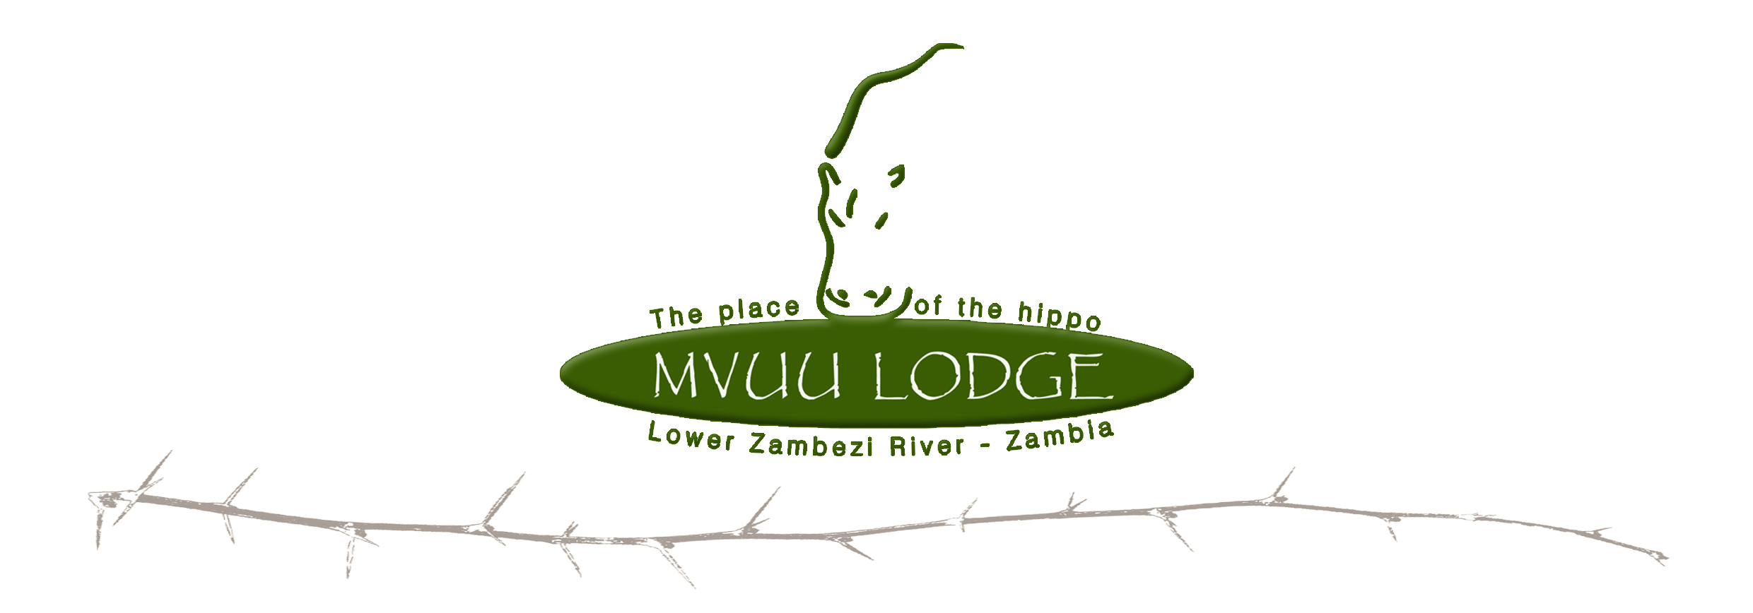

Directions:

As you drive into Chirundu you will find a “Chirundu Kaimon Bus Terminal” sign. Turn left at the second sign to go to the Pontoon.

From Chirundu it is 11km to the Pontoon crossing (K56 000 for a local car $30 for foreign registered cars per crossing 06:00 – 18:00). Take the right-hand-road at the Y-fork just after the Pontoon crossing (See signs to Kayila) - then its just under 25km to Chiawa village - you turn right into the village and the
road bends left out of the village. From Chiawa it’s another 25km to Mvuu Lodge, if you ever think you may be going wrong, ask a local, they are friendly and helpful!!
Lodge Managers:

Aidan Bolton +260 977 636 567

