FANTASIA GUEST HOUSE est. 1999
MEMBER OF THE ACCOMMODATION ASSOCIATION OF NAMIBIA AND REGISTERED WITH THE NAMIBIA TOURISM BOARD
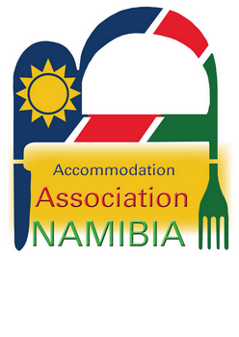

BRIAN SIMATAA ST. P.O. BOX 429 ONDANGWA NAMIBIA

TEL: +264 – (0)65 – 240528 FAX: 241014
e-mail : e-mail : fantasia@mweb.com.na
www.accommodation-association.com
VAT REG. No.: 0321885015

Fantasia Guest House is situated in the centre of Ondangwa, (Northern Namibia), close to the First

National Bank, and just off the Main Road (B1), as indicated by our signboards. We are 30km from

Oshakati and 7km from Ondangwa Airport and 60km from the southern border of Angola .

We offer eight comfortable fully furnished and serviced 2-bed bedrooms (bathroom en-suite), all air
conditioned in a secure area with shaded parking. Bedding and towels are supplied as well as coffee and tea.
Each room also has a TV, fridge, toaster and microwave with adequate cutlery and crockery. Our kitchen
and bar offer fine foods and drinks and a barbeque service is available. Laundry, phone, e-mail and fax
facilities are also available.

We are centrally situated for business / leisure trips to Oshikango, Ongwediva, Oshakati, Ruacana, Opuwo
and day trips to the Etosha National Park.
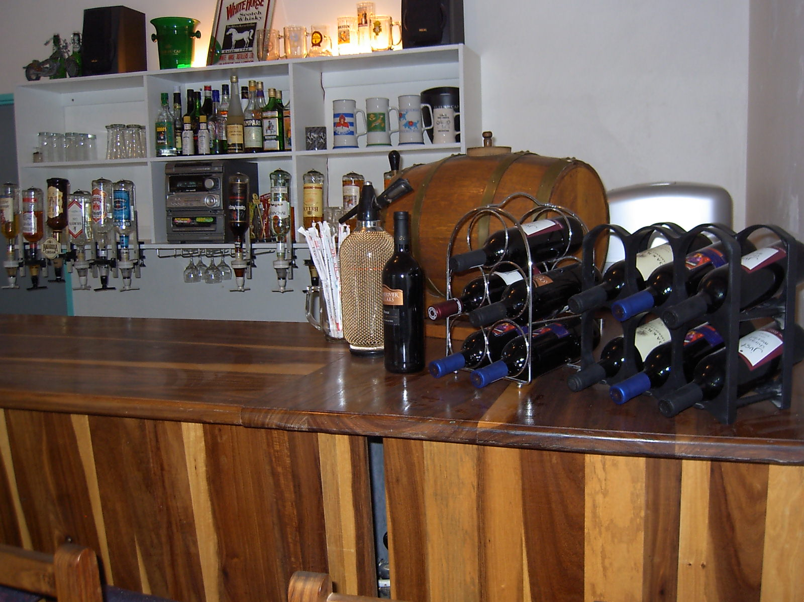
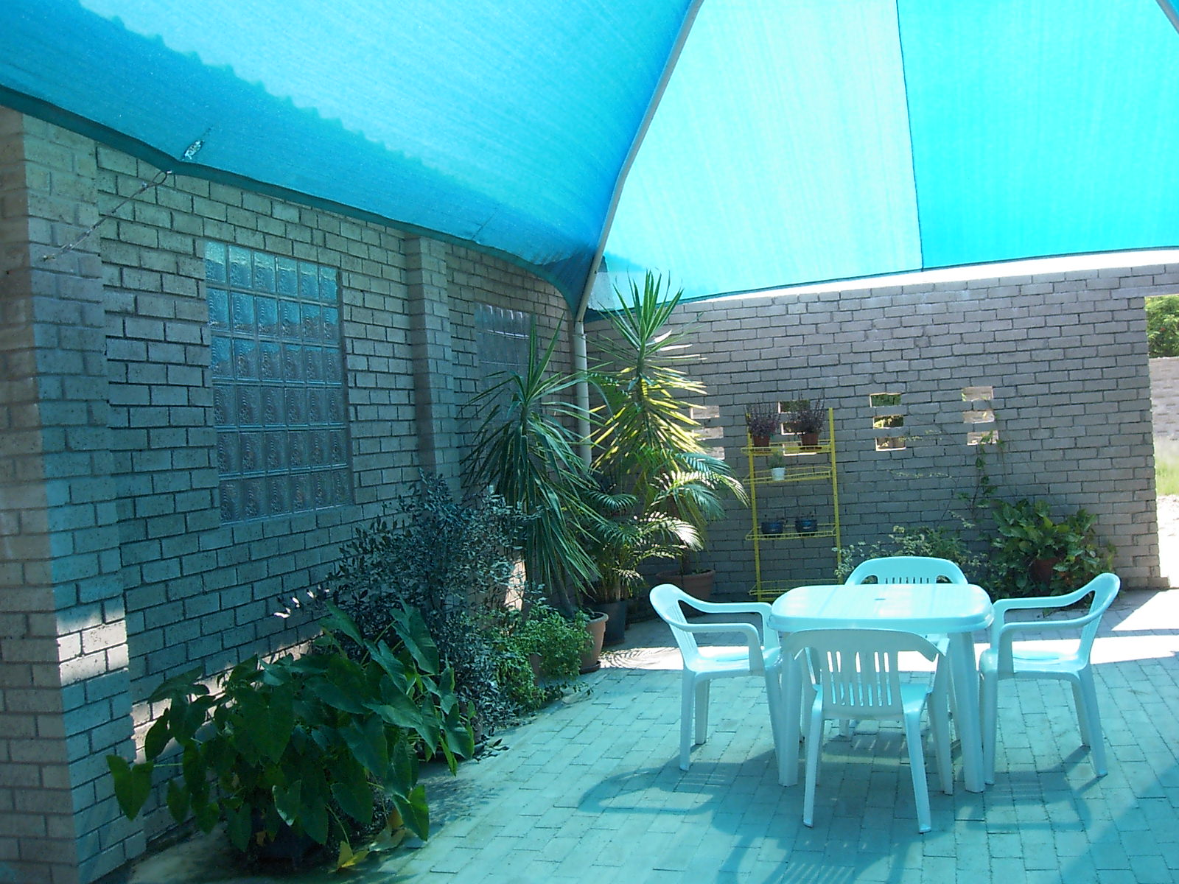

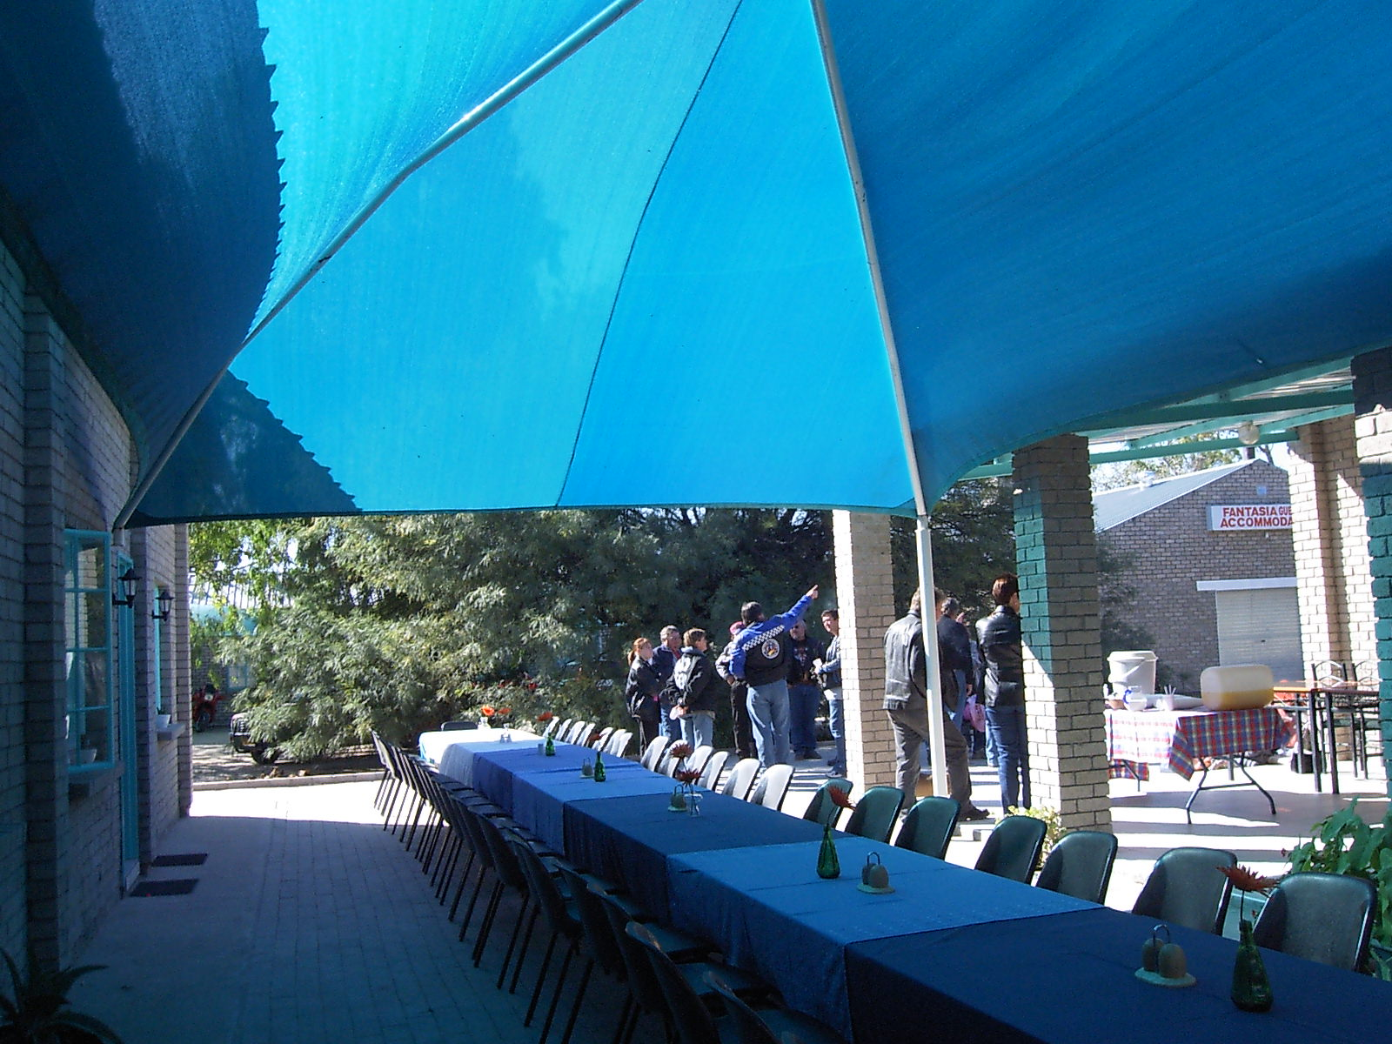
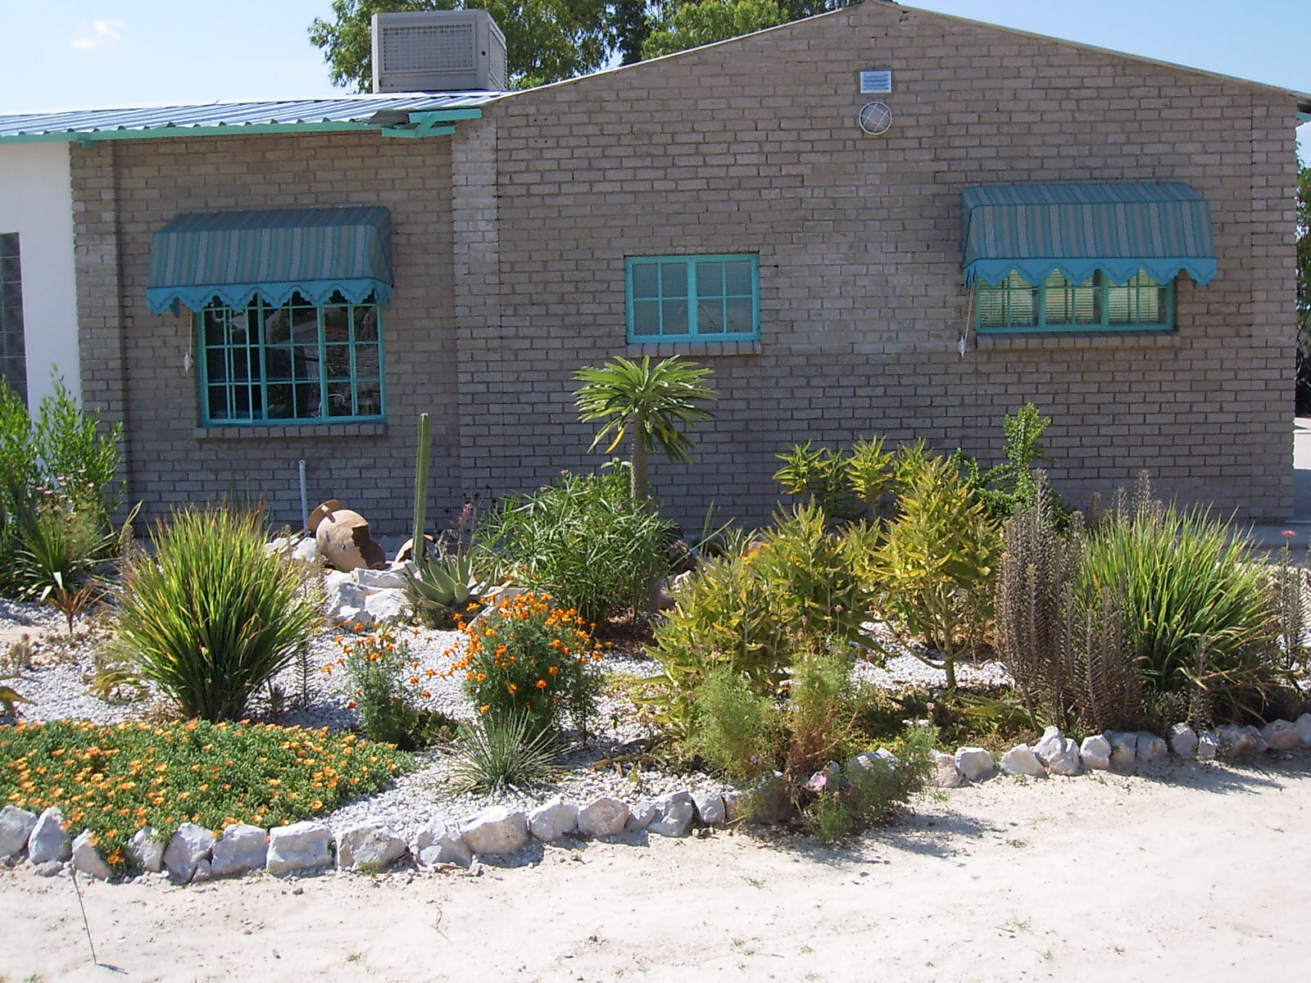

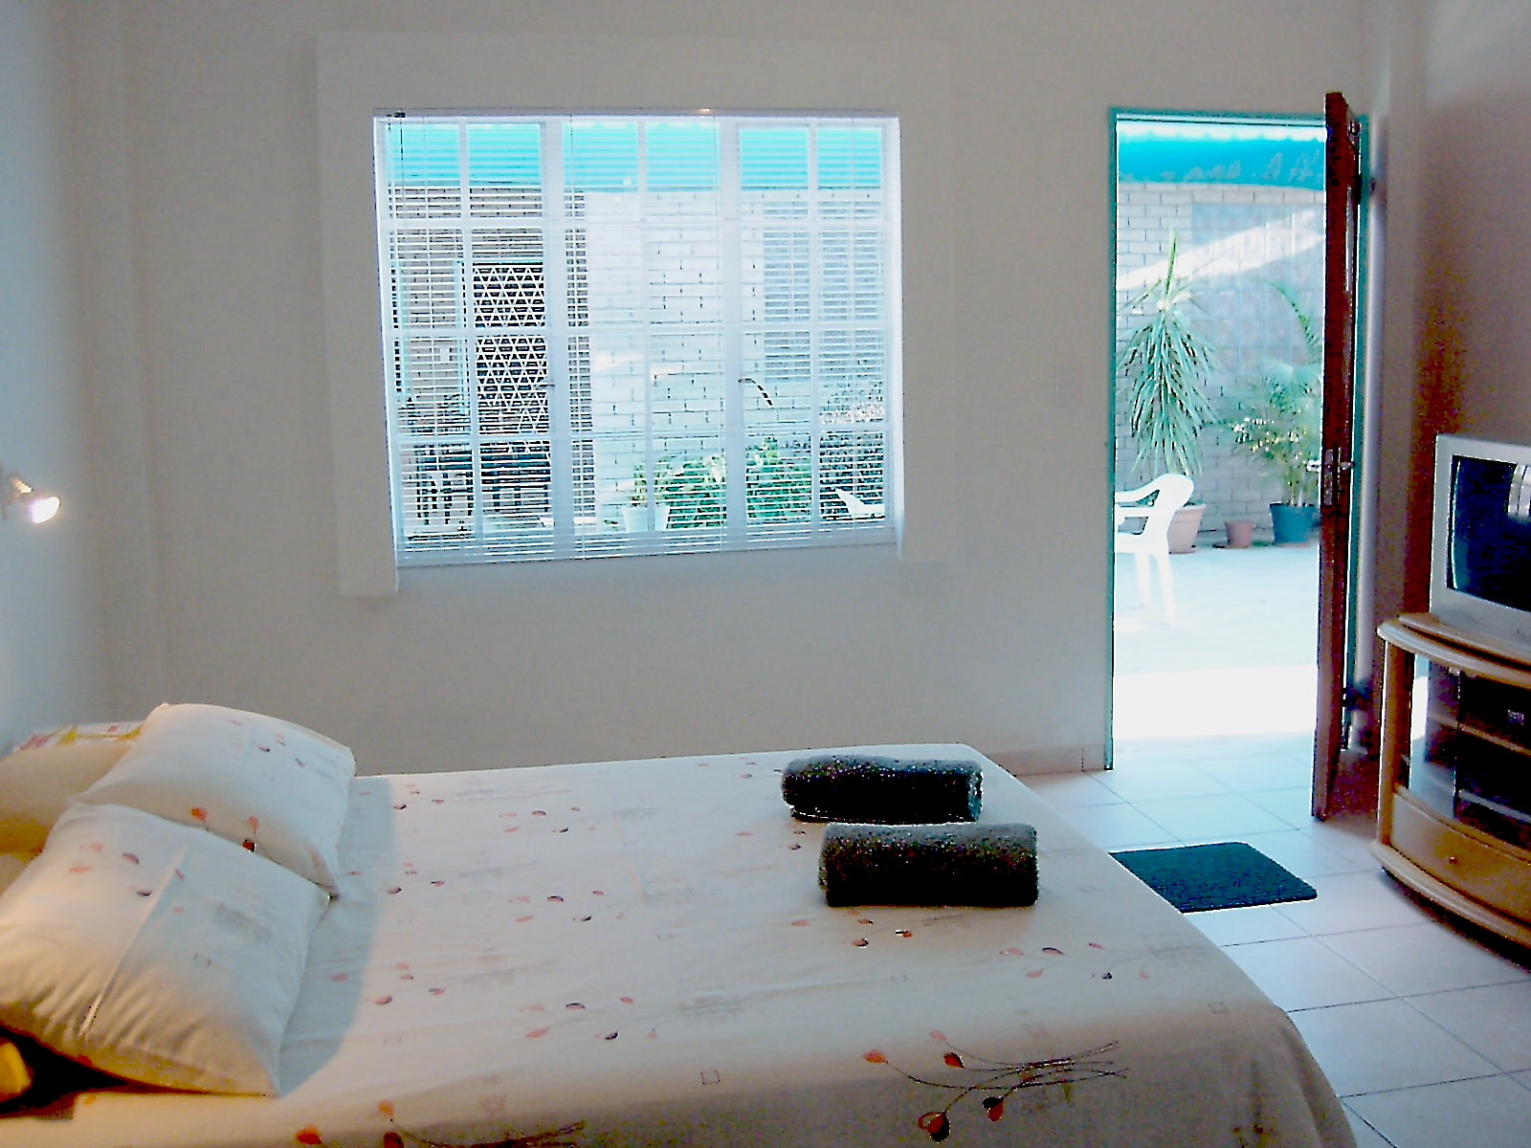
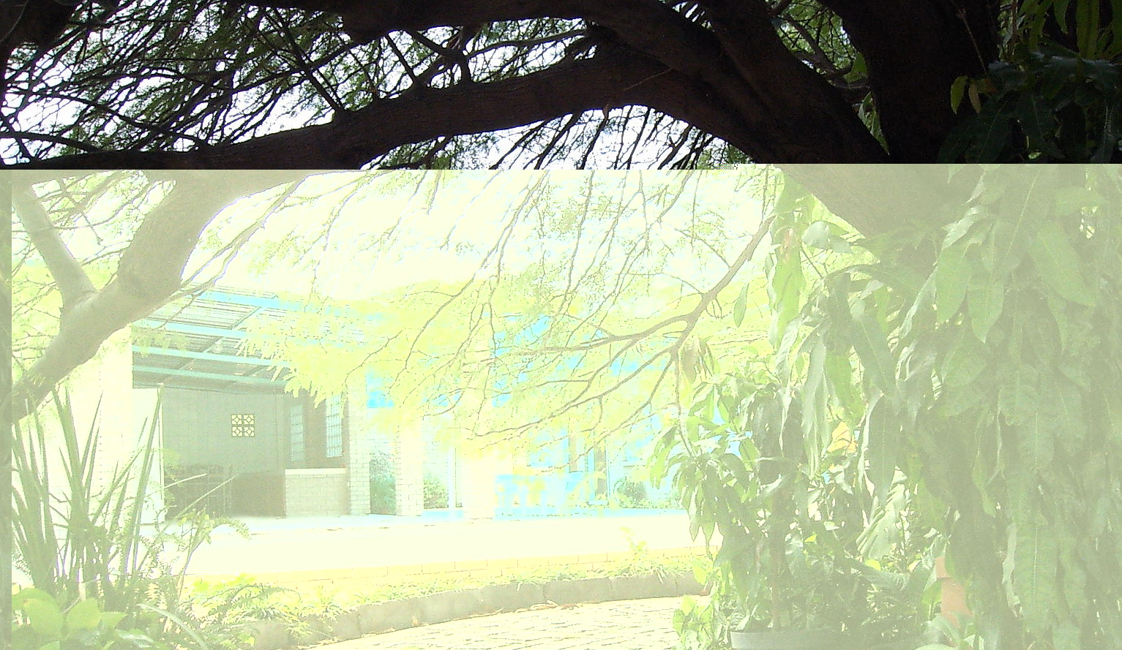

CONTACT US AT 065 240528 FOR WARM HOSPITALITY IN REAL COOL SURROUNDINGS

