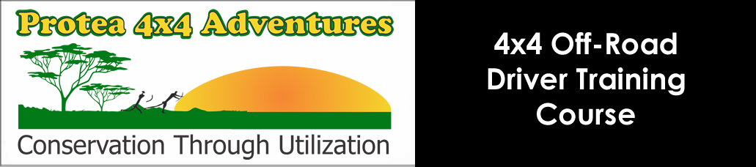

**Booking Form: 4x4 training course**

**Protea 4x4 Adventures offers 4x4 & 4x2 driver training courses for all makes of vehicles. Our endorsed 4x4 training academy aims to acquaint you with your vehicle’s four wheel drive systems as well as the exciting new lifestyle it will introduce you to if used in a Eco-friendly manner.**

**Name of Driver: ________________________________________________________________________________________**

**Number of Passengers: __________________________________________________________________________________**

**Vehicle: _______________________________________________Registration No: __________________________________**

**Cell no: _____________________________________ I.D. no: _________________________________________________**

**Email address: _________________________________________________________________________________________**

Protea 4x4 Adventures has designed a training course that is aimed at enabling you to make use of your vehicle in the way that it was designed to be used as a fun, exploration tool! Get away from the humdrum of city life and join them for a day at the Rhino & Lion Nature Reserve in the Cradle of Humankind World Heritage Site.

**The 4x4 training course fees will be R1 850. We also offer personalised 4x4 training courses during weekdays (you can suggest a few dates) at R3 250. Should you wish to bring additional guests/children; a cost of R300 per person will apply payable in cash on the day. To show our ongoing commitment to introduce you to new ways in which to enjoy your vehicle you will be kept informed about any new activities/safari tours/weekend breakaways that we have planned just for you.**

**The program for the day will be as follows:**

09:45 Registration and Welcoming drinks (Coffee/Tea) at the Protea 4x4 Track.

Theoretical discussion on sound off-road principles and the workings of your vehicle’s four-wheel drive systems and traction aids.

Depart on the first part of the 4x4 orientation section.

This section – an off-road game drive – serves to get you accustomed to the way that your vehicle reacts in various off-road situations and the correct 4x4 selection to be used for maximum traction and stability. The engaging and the operation of all the four-wheel drive systems and traction aids that your vehicle offers will be practiced during the first part of the day.

The aim is to put the morning’s theory into practice and to engage the correct four wheel drive system for specific types of terrain.

Break for a light lunch at the Kiosk area of the nature reserve. It’s time to visit the animal crèche and to interact with the animals.

Arrive back at the Protea 4x4 Driver Training Academy; a eco-friendly / vehicle friendly obstacle course, simulating most of the off-road conditions (with water & mud crossings, C-Saw bridge, ascending & descending sections, rocks, cross-axles, wooden bridges, mini pass and plenty more) found in Southern Africa, designed to practice you’re newly gained off-road skills and to put your vehicle through its passes. Preparing you for all those long planned expeditions you have planned into the Great African Outdoors.

Demonstration covering:

* Suggested vehicle recovery procedures, river crossing methods and Eco-friendly off-road driving techniques.
* Vehicle Accessories, Tyre Selection and suggested tyre pressures to be used for different types of terrain.
* Gear and Line selection in various scenarios including water fording, hill descends and ascents as well as

Cross-axle situations to mention just a few of the breathtaking experiences you will experience on the day.

16:00 Handing out of your Protea Competency Certificate – your certificate can be presented to your short-term insurer in order to qualify for a possible discount on your insurance premium.

It’s also your passport to endless adventures with your family and your 4x4 vehicle.

**The available dates are (please indicate your choice by ticking the appropriate date below):**

|  |  |  |
| --- | --- | --- |
| **Sunday 10 April 2016 - Full** | **Saturday 14 May 2016** | **Sunday 12 June 2016** |
| **Saturday 3 July 2016** | **Sunday 14 August 2016** | **Saturday 10 September 2016** |

**Please send your completed booking form to** [**info@protea4x4.co.za**](mailto:info@protea4x4.co.za)