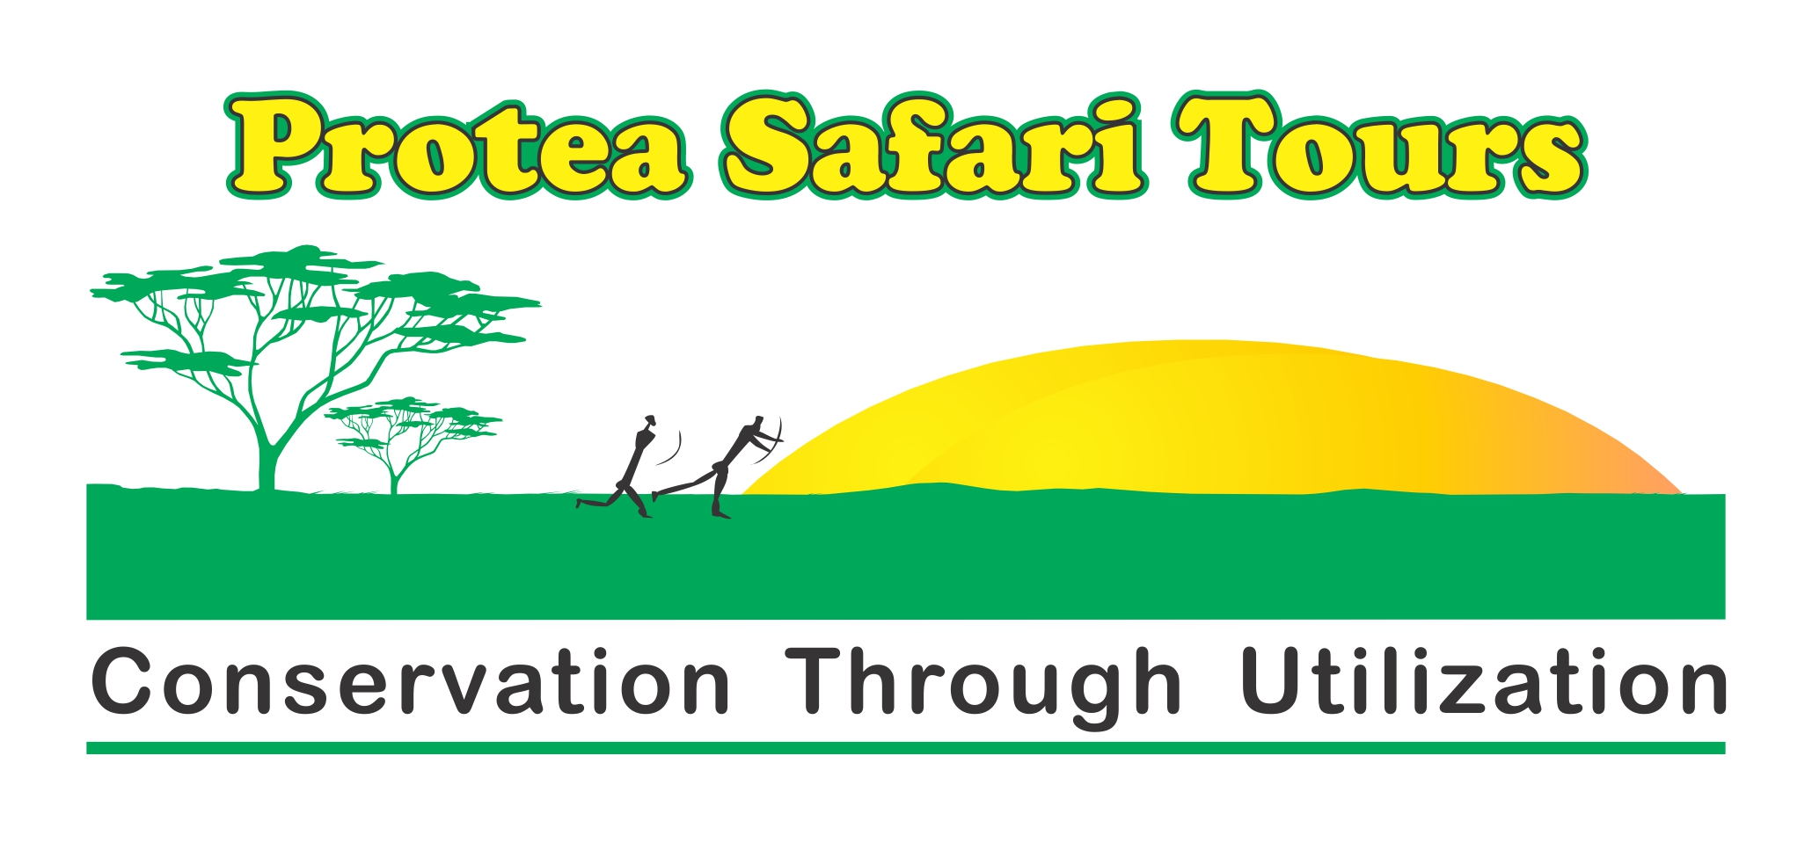

Safari Tours – 2016/17

Our guided safari fees are priced per person sharing; our safari tours are self-drive, self-catering, self-camping tours. We also offer fully catered safaris. It includes all your camping (all campsites offer full ablation facilities) or Lodge accommodation fees, listed activities and Park fees.
We guarantee confirmed reservation at all the reserves, camp sites and Lodges. Our world-class safari experiences are aimed at true nature lovers, a photographers dream and for those that enjoy the unspoilt wilderness areas of Southern Africa.
The aim of our Safari Tours is to treasure the conservation of these countries natural treasures and to enjoy the wonders of their pristine wilderness areas.
We offer a true safari-experience; of an unhurried life-changing journey which will not be forgotten soon. Our tours are not obstacle courses nor are they an endurance test.
Our Safari Tours are there for you to experience a typical African Safari holiday of a lifetime.

Mark these ones off your BUCKET LIST;

- Chobe Safari: 7 to 17 July 2016...Self-drive –– Botswana. A world class safari experience that you will not forget. The ideal photographic safari with an astonishing number of wildlife. Visit the Makgadikgadi Pans, Chobe National Park, Victoria Waterfalls. Early morning boat cruises, a sundowner cruise and dinner on the Chobe River. A 11 day/10 nights self-catering, camping-safari. Includes 4 catered dinners and 2 catered breakfasts at the Lodge @ R 18 600 per person sharing.
Can still accommodate 8 x people

- Sani Pass long weekend: 5 to 9 August 2016…Fully catered trip. Come and join us on this winter trip to the Drakensberg. This world renowned mountain pass is rated under one of the must drive mountain p[asses in the world. Enjoy a picnic at 3200m above sea level and experience a Basotho Village. This 5 day/4 nights long weekend trip with all Hotel-dinner/bed/breakfasts included will be R 6 400 per person sharing. We can only accommodate 12 x couples or 24 people, special rate for children sharing with parents.

- Namaqualand Flower Safari: 25 – 31 August 2016...Namaqualand, South Africa – Dinner, bed & breakfast. Our aim is for you to experience the unspoiled expanse of open spaces that is regarded as one of the world’s botanical wonders. Namakwa offers blazing Persian carpets of colourful daisies. Join us for the greatest flower show on earth! It’s a 7 day/6 nights tour at R 14 850 per person sharing.
Book now as we can still accommodate only 10 x people

- Moremi Safari: 21 to 31 October 2016...Self-drive, self-catering self-camping safari to the Moremi National Park, Botswana. The Okavango Delta is one of the last true Wilderness areas in the World and now a World Heritage site. Experience Africa’s wildlife like never before. A 11 day/8 nights self-catering, camping safari with 2 nights fully catered (dinner/breakfast) Lodge accommodation, a sundowner boat cruise @ R 16 800 per person sharing.

- Zebra Safari: 18 to 27 November 2016...Self-drive, Self-catering self-camping safari. Witness the arrival of thousands of plains Zebra on the vast open plains of Botswana as the rainy season starts. Regarded as the second largest migration in Africa by National Geographic. The annual migration of close to 30 000 Zebra and the astonishing strength and the sheer to survive is a must to experience. 10 days/9 nights camping safari @ R 14 900 per person.

- Leatherback Turtle Safari: 19 to 23 January 2017…Northern KZN – Dinner/bed & breakfast. Snorkel at Kosi Bay mouth, visit the 700 year old Tsonga Fish Kraal’s and participate in this tradition of spearing a fish. Surges for a sea turtle that’s busy laying her eggs and experience the hatching of Loggerhead and Leatherback Sea Turtles on a secluded beach. This will be one of your closest encounters with an endangered phenomenon. A boat cruise on the lakes and the opportunity to snorkel amongst the fish kraals. A weekend with plenty sandy tracks. If you are ready for an adventure of note, book now for this 5 day/4 nights fully catered experience at only R10 500 per person sharing. BOOK NOW

- Zebra Safari: 7 to 16 April 2017...Self-drive, self-catering, camping safari. This is a BUCKET LIST lifestyle experience. Be part of the second largest migration in Africa!! This safari is a photographer’s dream, ideal for those that really admire the miracles of nature. A 10 day/9 nights camping safari @ R 14 900 per person.

- Namib Desert Safari: 12th May to the 26th May 2017...Self-drive, self-catering, self-camping safari to Southern Namibia. This boutique safari expedition offers; fascinating landscapes, breath-taking scenery, diverse cultures and a rendezvous with nature. A world class safari experience that you will not forget. Experience the oldest Desert in the world, Ghost Town of Kolmanskop, Fish River Canyon, Duwisib Castle and Sossusvlei, Swakopmund and a desert adventure of note. 15 days/14 nights camping safari that includes two dinners & three breakfasts at Lodges. @ R 17 800 per person sharing. Limited space available.

Please feel free to contact Jannie Rykaart (4x4 Trails and Overland Guide-GP 5097) your host for these Safari Tours to assist you with any questions concerning the planning of your Safari Tour with us.

Please take note that the above rates may change and is subject to a minimum of six bookings. You can contact me on 083-268-0566 or e-mail me: info@protea4x4.co.za or visit www.protea4x4.co.za or visit/like/share our facebook page for more visuals on the above at “protea 4x4 adventures”

Unbelievable offer!!!
Make a booking for one of our safari tours and Mitsubishi Motors will lend you a five-door Pajero for the duration of the trip – at no extra cost!

You only live once, but if you do it right, once is enough Mae West

Endorsed by:

Mitsubishi Motors South Africa, Jeep Midrand & Bedfordview, Rivonia Toyota, Volvo Westrand,
Conqueror Trailers North Gate, Kennis Caravans & Campworld Roodepoort and Imperial Campworld & Safari Centre’s

May 2016

